Logitech in the News

Do you hear the school bells ringing? We cannot deny it anymore; class is officially back in session. Cheer up though! Logitech is here to make the back-to-school season and studying more fun. Read on to see what Logitech products were featured in the news this week.

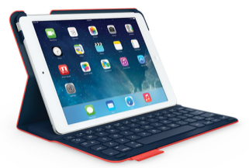
Are you heading off to college this year and in need of a good keyboard for your iPad? Check out the Logitech Ultrathin Keyboard Folio for iPad Air, which Gurl.com is “obsessed” with. They consider it a “must-have for students.” You can also win the Logitech Ultrathin Keyboard Folio on Gurl.com here just make sure to enter the giveaway before Sept. 12!

Examiner.com included two Logitech products in its Back-to-School Tech Guide, which highlighted must-have tech gadgets for the new school year. They featured the Logitech Illuminated Living-Room Keyboard K830 as the perfect tool to navigate between your TV and computer while studying, and the UE BOOM for its BOOMING sound.

Let’s Play OC attended last week’s Bemo pop-up event in Los Angeles, and shared pictures and highlights from the night. Their blog post noted that Bemo, “…is meant to be taken anywhere and everywhere like a GoPro but much more user-friendly.” The blog post also shared details on the Creative Collective so make sure you check it out!

Part 2 of a review of the Logitech ConferenceCam CC3000e appeared in Let’s Do Video. The reviewer praised the CC3000e for the camera quality, ease of installation and affordability. He concluded, “Whether used in conjunction with MS Lync, Skype, Hangouts or larger systems from Polycom or LifeSize, it’s a solid solution for a mid-to-largish meeting room.”

